SOLVING SIMULTANEOUS EQUATIONS GRAPHICALLY
Pearson Edexcel – Monday 8 June 2020 - Paper 3 (Calculator) Higher Tier
1.
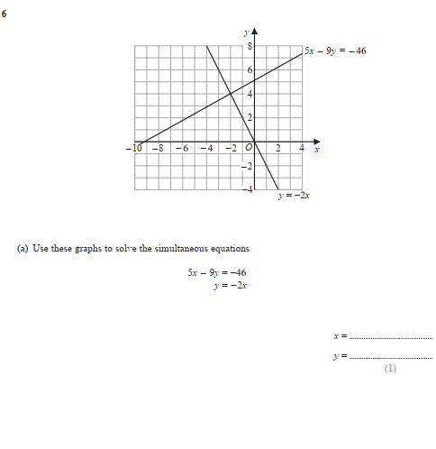
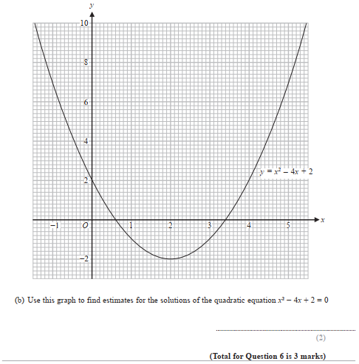

Pearson Edexcel - Tuesday 21 May 2019 - Paper 1 (Non-Calculator) Higher Tier
2.
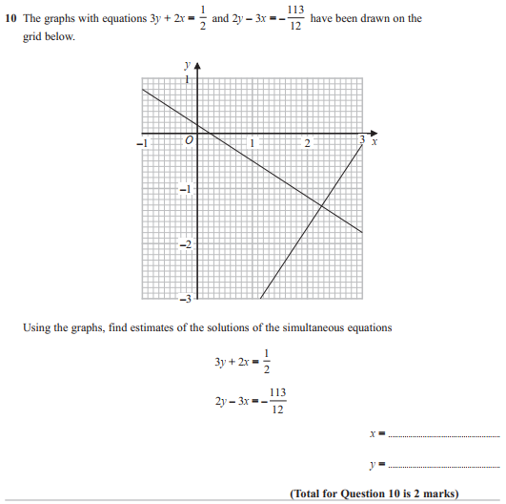

OCR GSCE – Thursday 5 November 2020 – Paper 5 (Non-Calculator) Higher Tier
3.
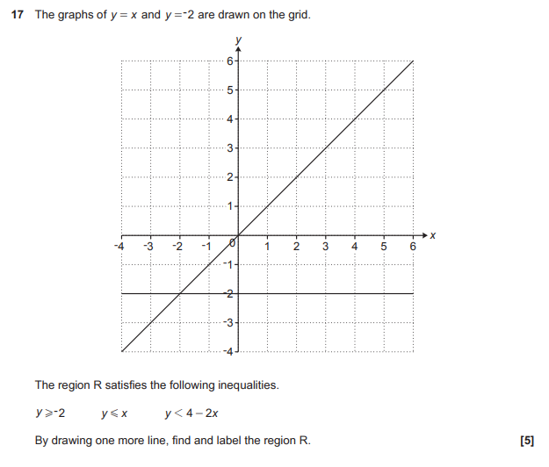

OCR GSCE – Monday 9 November 2020 – Paper 6 (Calculator) Higher Tier
4.
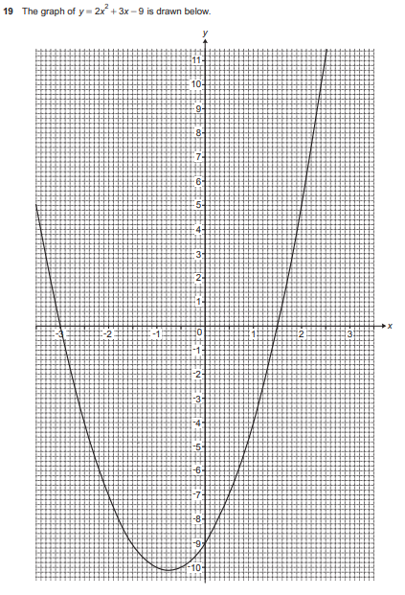
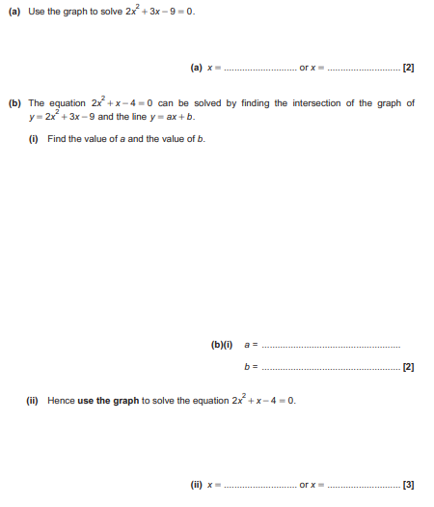

OCR GSCE – Thursday 7 November 2019 – Paper 5 (Non-Calculator) Higher Tier
5.
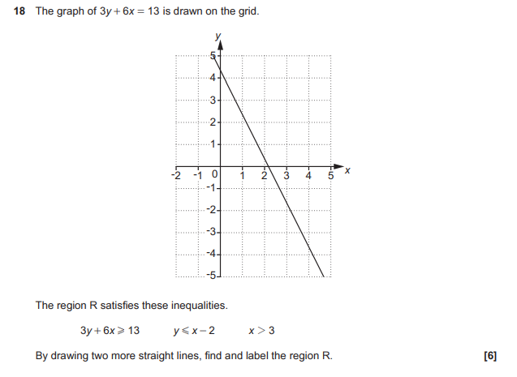

OCR GSCE – Tuesday 21 May 2019 – Paper 4 (Calculator) Higher Tier
6.
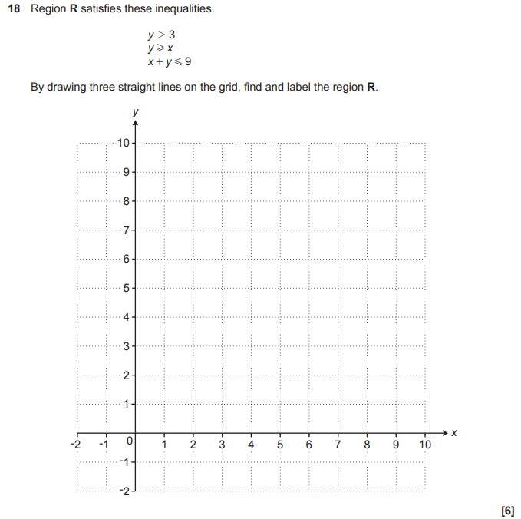

OCR GSCE – Thursday 6 June 2019 – Paper 5 (Non-Calculator) Higher Tier
7.
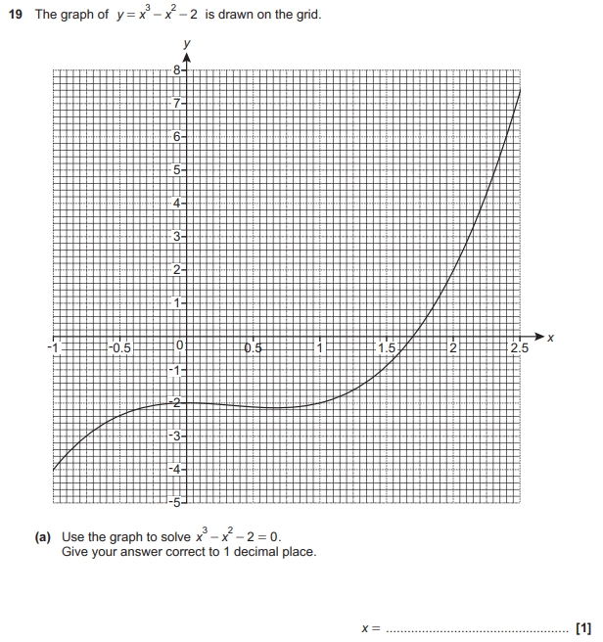
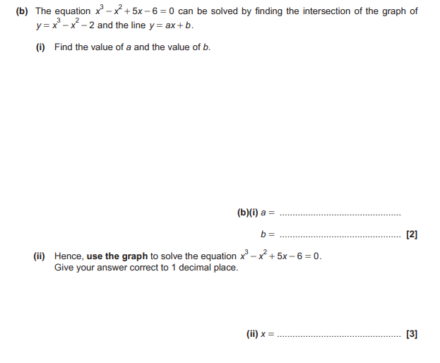

OCR GSCE – Tuesday 6 November 2018 – Paper 4 (Calculator) Higher Tier
8.
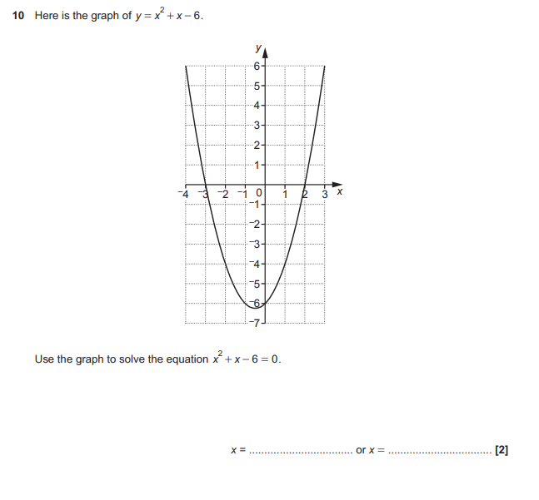

OCR GSCE – Thursday 8 November 2018 – Paper 5 (Non-Calculator) Higher Tier
9.
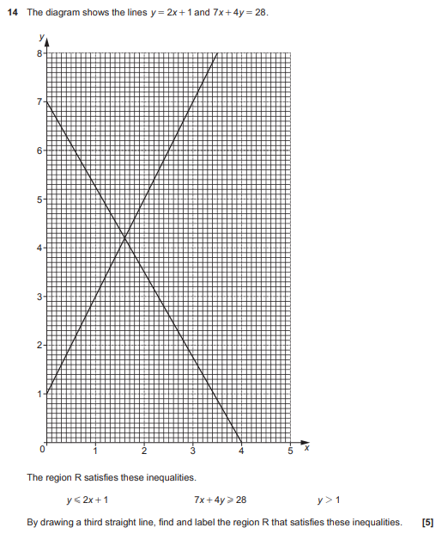

OCR GSCE – Tuesday 12 June 2018 – Paper 6 (Calculator) Higher Tier
10.
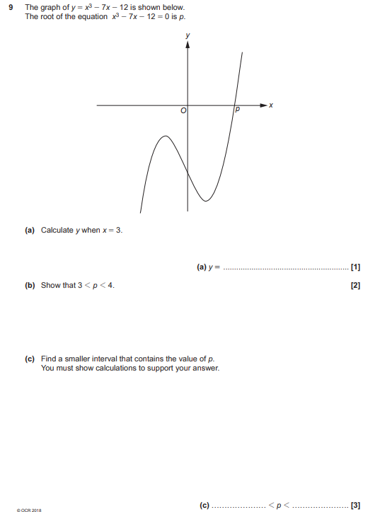

OCR GSCE – Wednesday 8 November 2017 – Paper 6 (Calculator) Higher Tier
11.
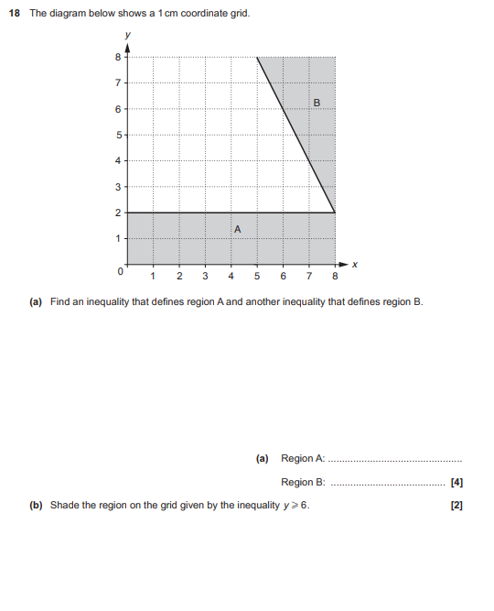
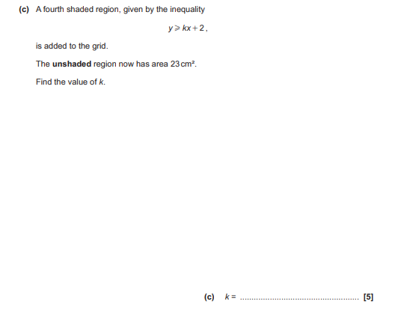

AQA GSCE – Thursday 8 June 2020 – Paper 3 (Calculator) Higher Tier
12.
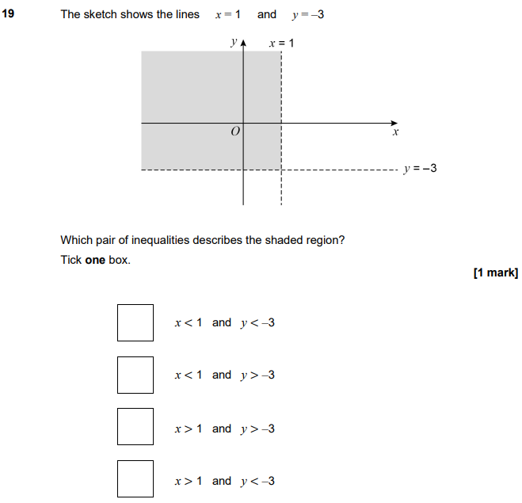

AQA GSCE – Thursday 6 November 2017 – Paper 2 (Calculator) Higher Tier
13.
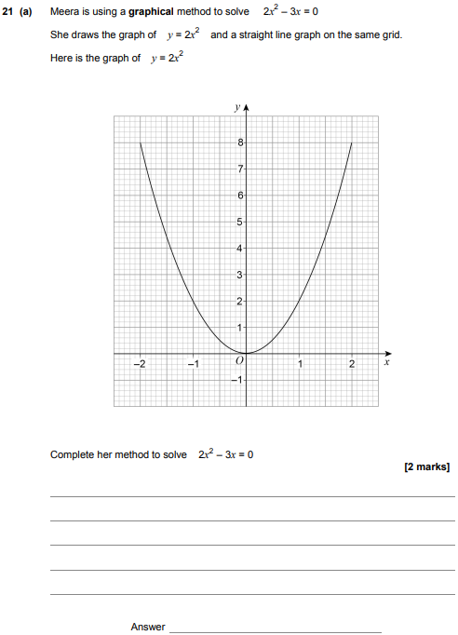
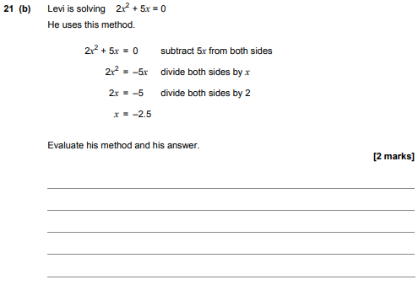
AQA GSCE – Wednesday 8 November 2017 – Paper 3 (Calculator) Higher Tier
14.
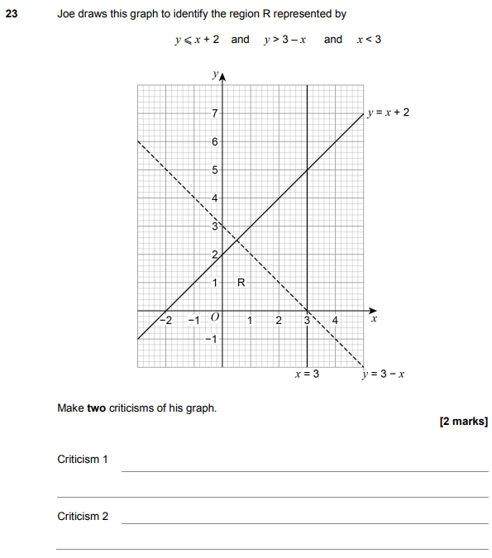

AQA GSCE – Wednesday 8 November 2017 – Paper 3 (Calculator) Higher Tier
15.
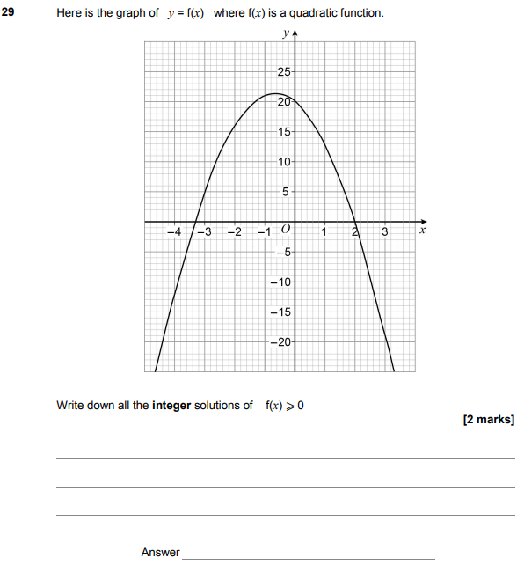

AQA GSCE – Tuesday 13 June 2017 – Paper 3 (Calculator) Higher Tier
16.
